23-5-2022 salini k.b
Mca-b
Roll no :33

Aim:Docker installation.

Steps for Installing Docker:
procedure
1. Open the terminal on Ubuntu.
2. Remove any Docter files that are running in the system, using the following command
sudo apt-get remove docker docker-engine docker.io
After entering the above command, you will need to enter the password of the root and press enter.

3]Check if the system is up-to-date using the following command:

$ sudo apt-get update
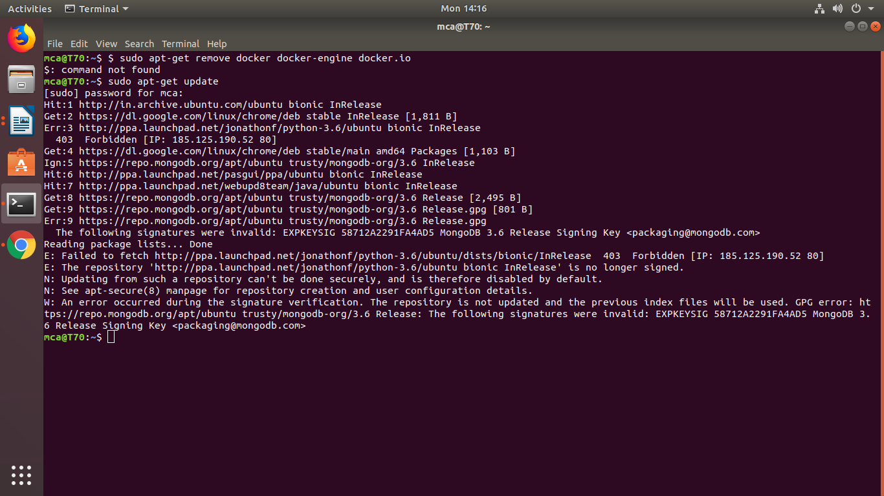

4. Install Docker using the following command:

$ sudo apt install docker.io

You’ll then get a prompt asking you to choose between y/n - choose y
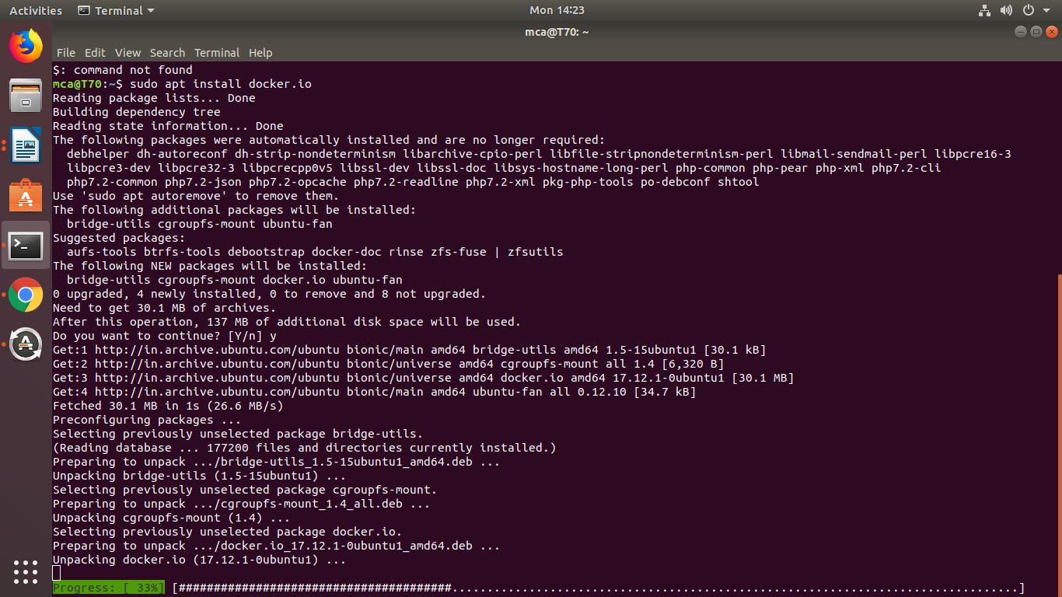

5. Install all the dependency packages using the following command:

$ sudo snap install docker

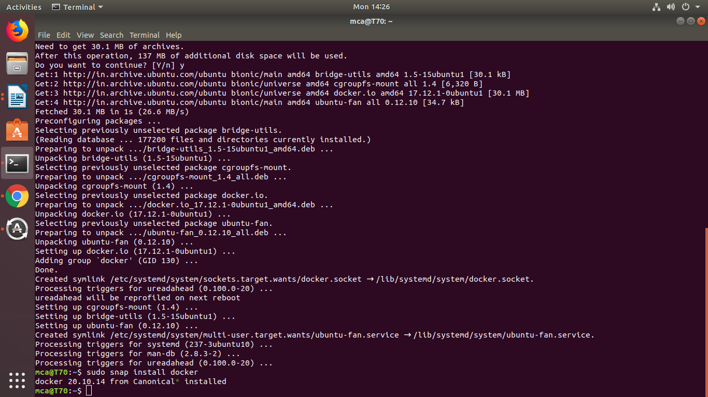

6. Before testing Docker, check the version installed using the following command:

$ docker –version

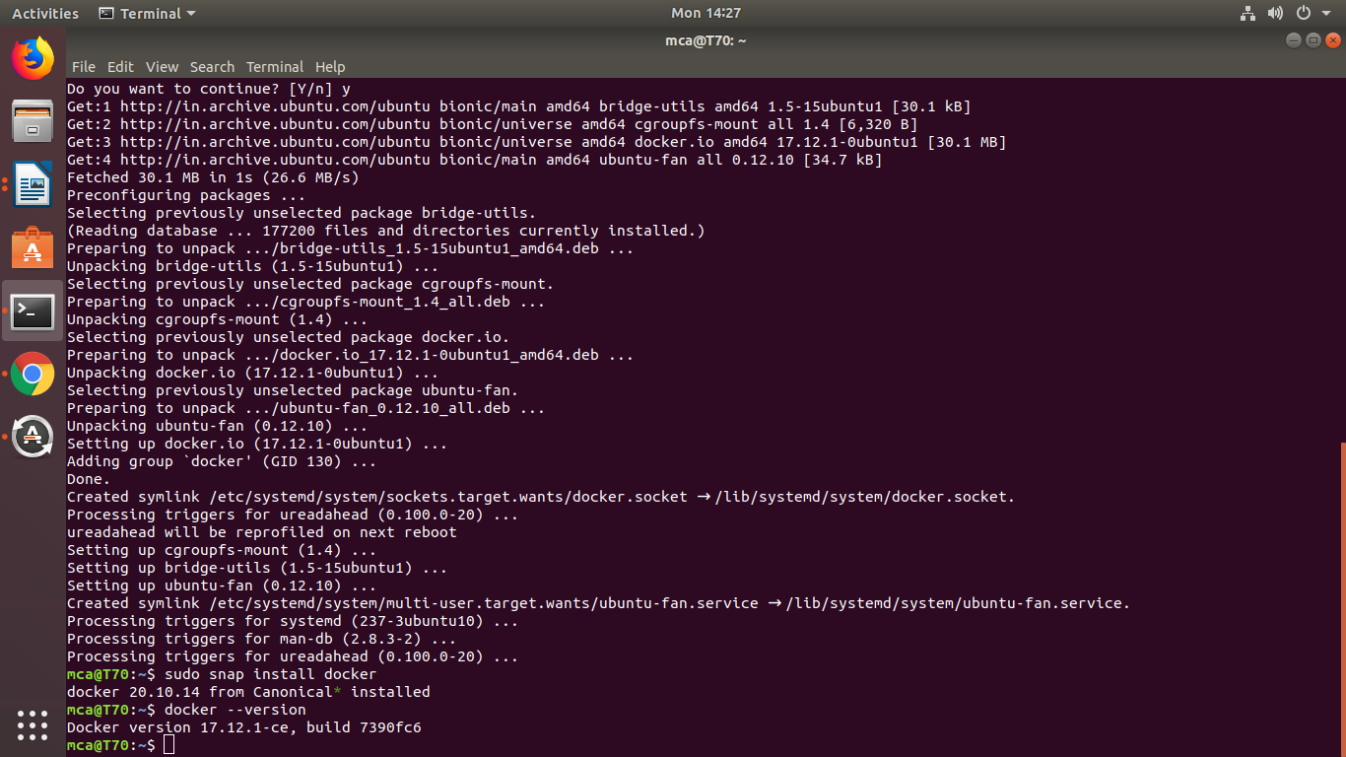

7. Pull an image from the Docker hub using the following command:

$ sudo docker run hello-world

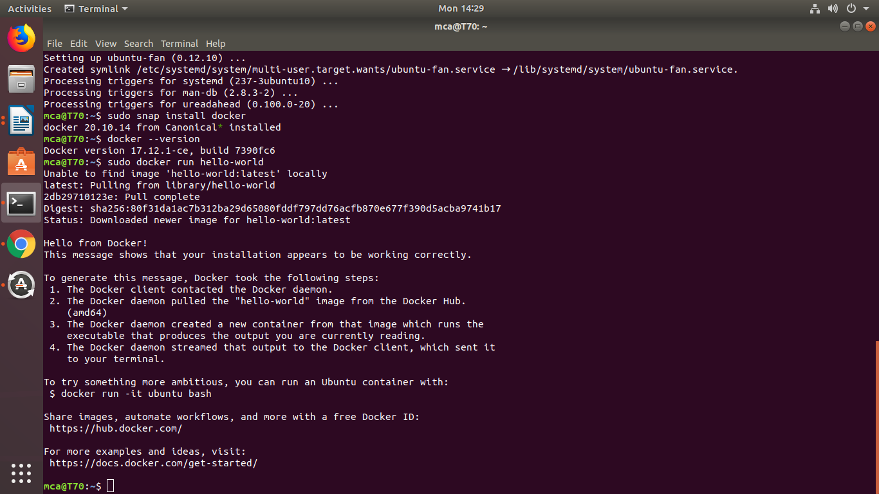

Here, hello-world is the docker image present on the Docker hub.

8. Check if the docker image has been pulled and is present in your system using the following command:
$ sudo docker images

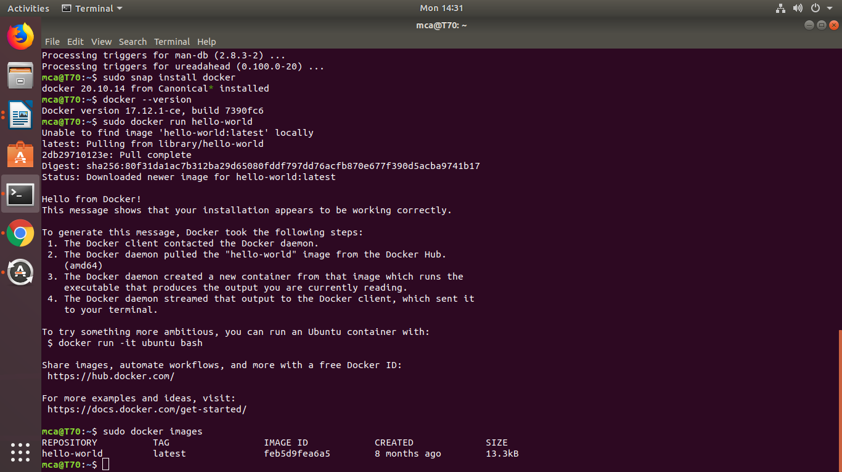

9. To display all the containers pulled, use the following command:

$ sudo docker ps -a
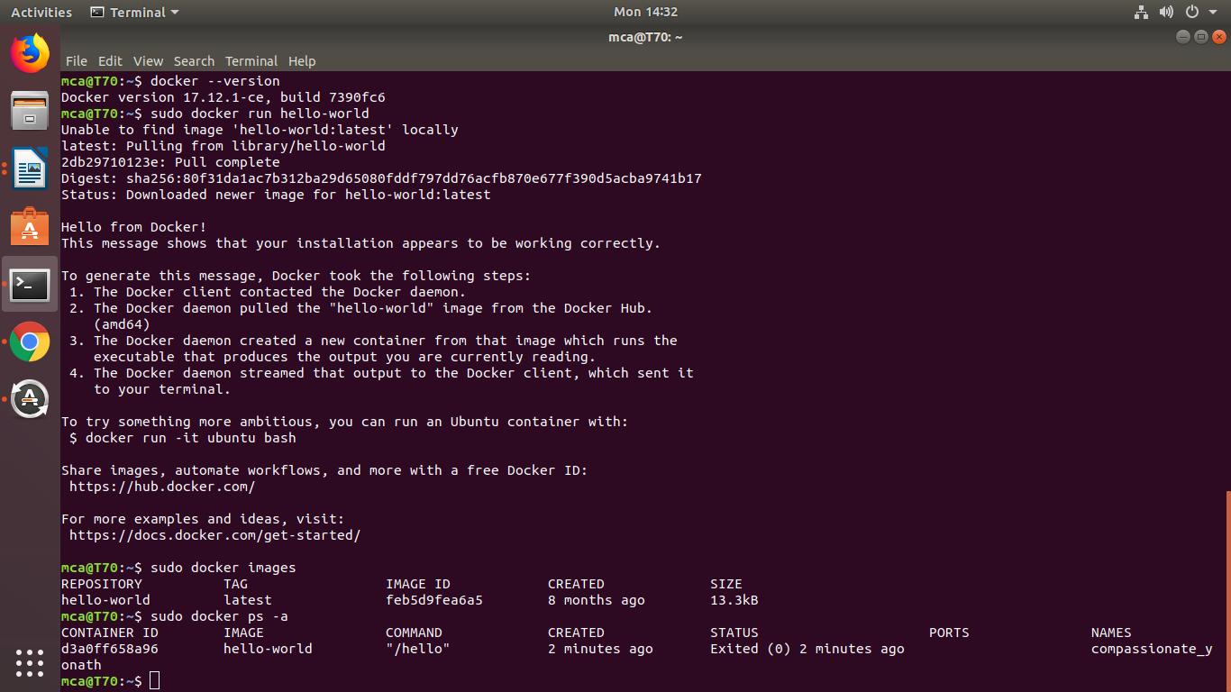

10. To check for containers in a running state, use the following command:
$ sudo docker ps

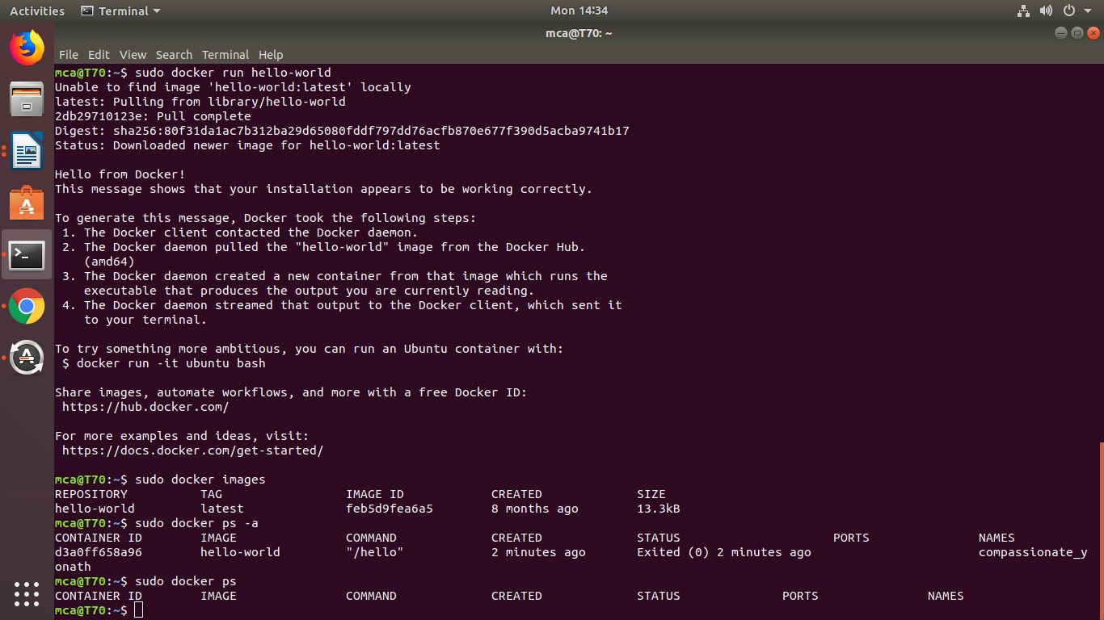
You’ve just successfully installed Docker on Ubuntu!

Aim: Setting Up an Apache Container

One of the amazing things about the Docker ecosystem is that there are tens of standard containers that you can easily download and use.
In the following example, we will instantiate an Apache 2.4 container named tecmint-web, detached from the current terminal. We will use an image called httpd:2.4 from Docker Hub
Our plan is to have requests made to our public IP address on port 8080 be redirected to port 80 on the container. Also, instead of serving content from the container itself, we will serve a simple web page from /home/user/website.
We do this by mapping /home/user/website/ on the /usr/local/apache2/htdocs/ on the container. Note that you will need to use sudo or login as root to proceed, and do not omit the forward slashes at the end of each directory.
Step-1
$ sudo docker run -dit --name tecmint-web -p 8080:80 -v /home/user/website/:/usr/local/apache2/htdocs/ httpd:2.4

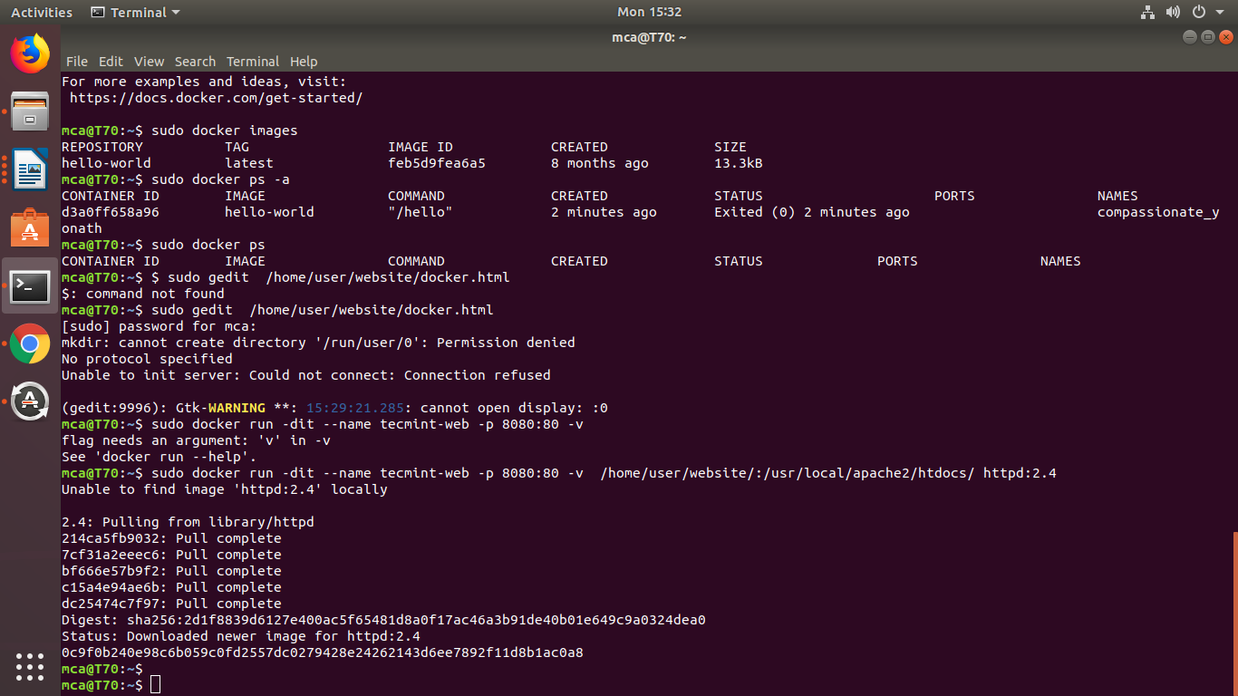

Pull Docker Apache Container
At this point, our Apache container should be up and running.
Step-2
$ sudo docker ps

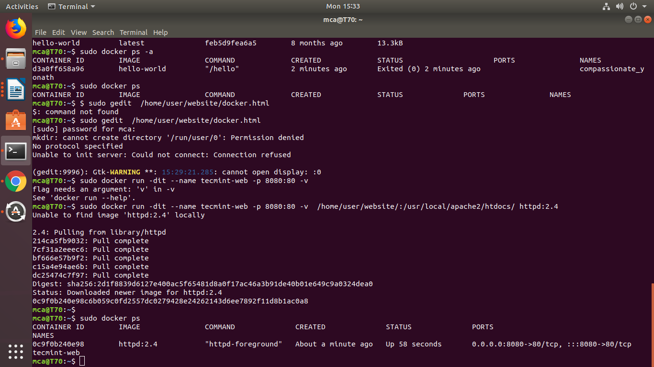

Check Apache Docker Container
Now let’s create a simple web page named docker.html inside the /home/user/website directory.
Step-3
$ sudo gedit /home/user/website/docker.html
Add the following sample HTML content to the file.
<!DOCTYPE html>
<html lang="en">
<head>
<meta charset="UTF-8">
<title>Learn Docker at Tecmint.com</title>
</head>
<body>
<h1>Learn Docker With Us</h1>
</body>
</html>

Next, point your browser to Server-IP:8080/docker.html (where Server-IP is your host’s public IP address). You should be presented with the page we created previously.
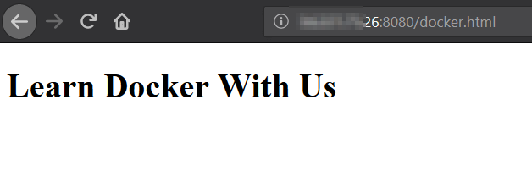Check Apache Page
If you wish, you can now stop the container.
Step-4
$ sudo docker stop tecmint-web

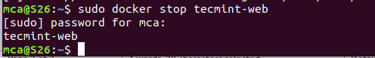

and remove it:
step-5
$ sudo docker rm tecmint-web

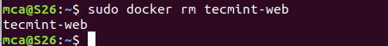

To finish cleaning up, you may want to delete the image that was used in the container (omit this step if you’re planning on creating other Apache 2.4 containers soon).
Step-6
$ sudo docker image remove httpd:2.4

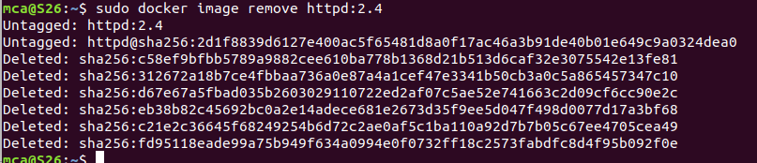

Note that in all the above steps we never had to install the webserver on our host.

